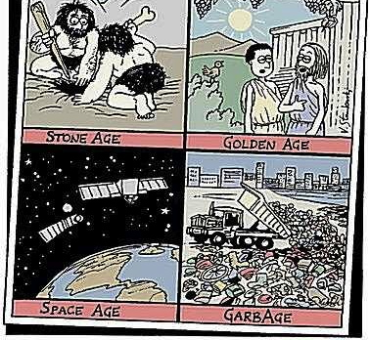
Issues in Canadian Geography - Grade 9, Academic

Environmental Justice: Talking Trash Cartoon Assignment

Thinking | Communication
/10 | /15

Due Date: _______________________________

Steps – check off when complete:
- Review the “What a Waste” fact sheet
- Choose 1 to 2 facts that shock/concern you
- Create a funny cartoon that illustrates the fact(s) you choose.
- Evaluate your cartoon using the criteria below

Rules – your cartoon must:
- show your fact(s) using pictures & images
- appeal to students at LPCI
- Include one caption or speech bubble in your cartoon to help communicate your main message

Evaluation
Thinking
- Cartoon shows planning and critical thinking by including appropriate symbols/characters to represent message | 0 1 1.5 2 2.5 3 3.5 4 4.5 5
- Message and artwork appeals to students at LPCI | 0 1 1.5 2 2.5 3 3.5 4 4.5 5

Communication
- Main message reflects fact and is clear and easy to interpret | 0 1 1.5 2 2.5 3 3.5 4 4.5 5
- Includes at least one caption/speech bubble that helps to illustrate main message | 0 1 1.5 2 2.5 3 3.5 4 4.5 5
- Uses colour and/or shading to effectively communicate the message of the cartoon. | 0 1 1.5 2 2.5 3 3.5 4 4.5 5

