ARTICLE 1

Share the mineral wealth, say First Nations
March 21, 2013
By: Northern Ontario Business Staff

Engagement with First Nations and respecting treaty rights must be “cornerstones” of this week's federal budget, said Nishnawbe Aski Nation Grand Chief Harvey Yesno.
“Canada will not achieve its full potential unless First Nations are engaged in a meaningful way in the development of our traditional lands and wealth of resources they contain,” said Yesno, in a March 20 press release.
Leadership within the Thunder Bay-based political and policy organization is calling on Ottawa to “renew its treaty relationship with First Nations” by respecting treaty right and supporting agreement that ensure that they share in the wealth generated by natural resource extraction.
“First Nations are fed up with being portrayed as a burden on taxpayers and are ready to play a major role as contributors to the economic growth of Canada. We are not against development, but need to have meaningful input into decision-making on critical issues that directly affect our people and our lands.”
Aboriginal people and their role in the economy is expected to be a focus in Finance Minister Jim Flaherty's budget.
In a release, NAN said many of the 49 communities it represents are coming under pressure in their traditional territories from industry arriving to develop natural resources, but many First Nation people still live in “Third World living conditions” without clean drinking water, adequate healthcare, fire and police services, and proper housing.
“Implementation of Treaty No. 9 and the Ontario portion of Treaty No. 5 is fundamental to developing a respectful relationship with the people of Nishnawbe Aski as the treaties set the basis for our relationship with the Crown, as represented by the Government of Canada,” said Yesno. “The treaties have not expired, and the highest courts in the land and international law have found that they are just as valid now as they were 100 years ago.”

Mining Cartoons
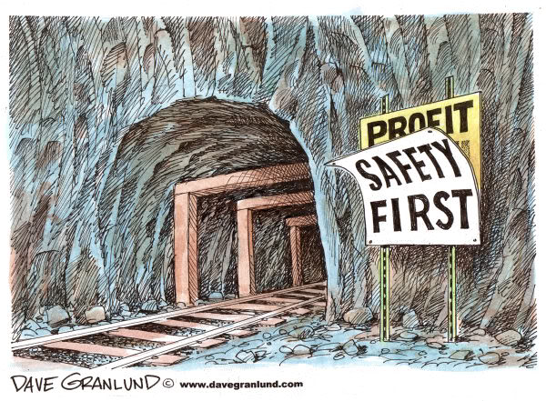

Mining Cartoons
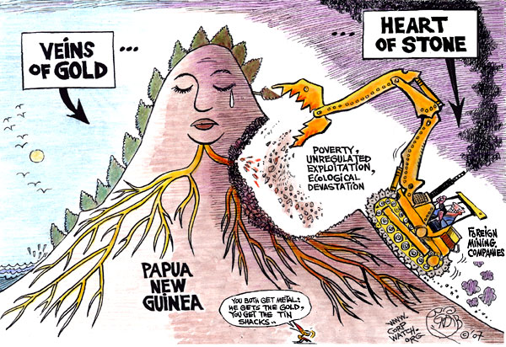

Infographic
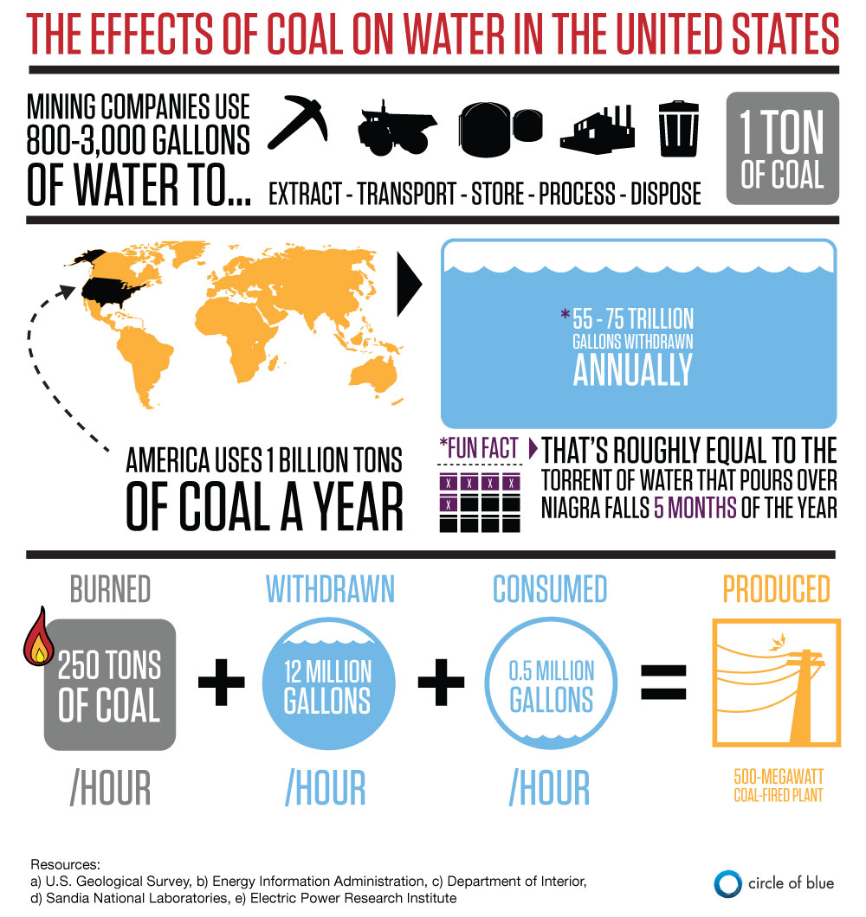

Infographic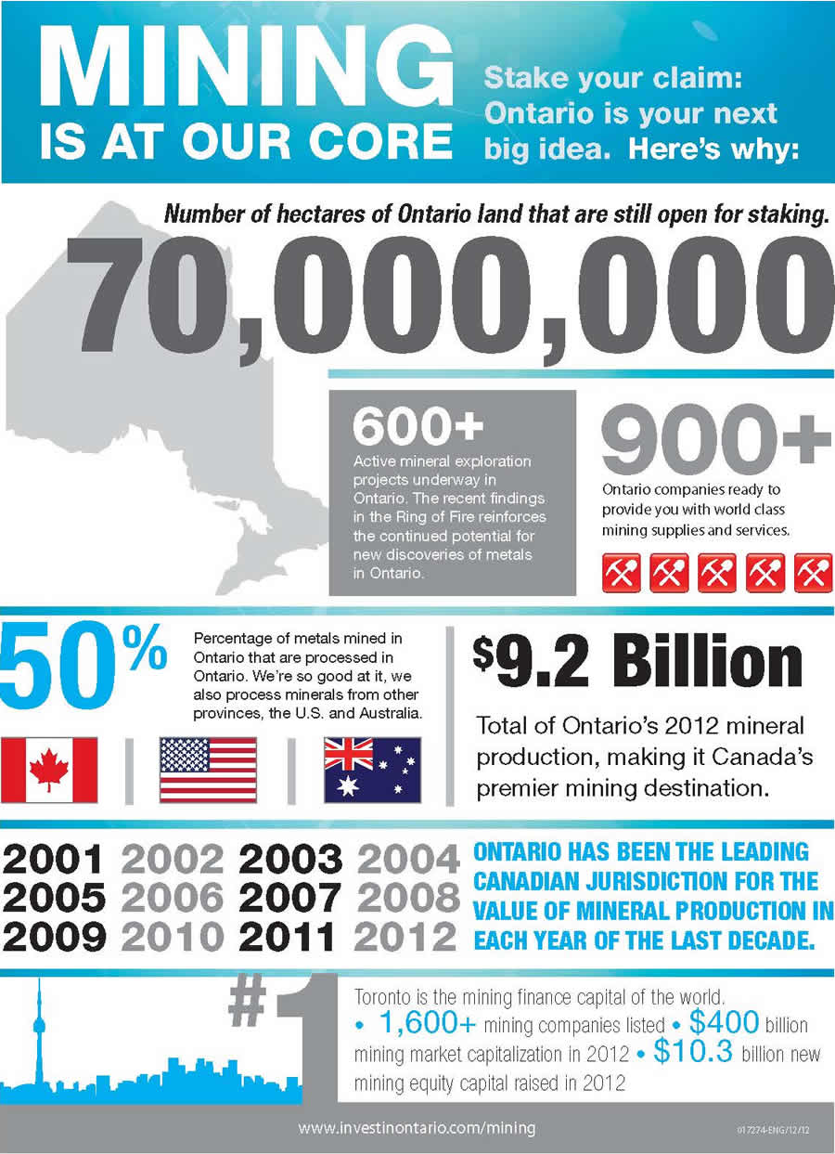

ARTICLE 2

Canada must do much more to promote ethical mining

Canada's efforts to promote ethical mining amount to no more than tap-dancing on the tip of an enormous iceberg of problems.
CIDA = Canadian International Development Agency
NGO – Non-Governmental Organization
By: Natalie Brender, March 11, 2013
Recent months have seen heated debate about CIDA’s venture into funding partnerships between Canadian mining companies and international development NGOs. Earlier in March, CIDA Minister Julian Fantino told a gathering of international resource companies, government officials and NGOs that Canada’s venture into such partnerships is part of a larger vision for the mining sector. “A responsibly managed extractive sector,” he said , “can drive sustainable economic growth, lead to more gainful employment, and provide more resources for families and their communities.”
Fantino’s words make it sound as though an ethically responsible approach to mining is already well understood, lacking only a bit of willpower, cooperation and funding to be put into effect. With the right management, he implies, mining can deliver ‘wins’ all around—for mining companies, Canadian and foreign governments, the environment and local communities.
High on that list of sound management techniques are apparently efforts such as the CIDA-funded projects in the area of corporate social responsibility, which see mining companies aiming to improve communities in the locales of their mining sites. Coming at the issue from another angle, Canada also has a strong track record in advocating for voluntary measures such as transparency initiatives (which seek to make public the financial transactions between mining companies and governments) and compacts to stem the flow of minerals bound up with armed conflicts.

Doubtless these initiatives do some good. As appealing as they are, however, they amount to tap-dancing on the tip of an enormous iceberg of problems besetting the global mining industry. Such is the argument made in a disturbing recent article , “The Missing Ethics of Mining,” written by Shefa Siegel, a Canadian journalist and scholar with degrees in environmental policy and mining engineering. For many decades, he observes, renewable resources such as agriculture, fishing and forestry have been scrutinized with respect to their impacts on development and the environment. But the ecological and human sustainability of mining, by contrast, has received almost no comprehensive ethical study. The survey he presents of what an ethics of mining should deal with reveals a massive array of appalling current practices.
As Siegel shows, today’s global mining industry involves the twin problems of scarcity and monopolization. Scarcity exists because the world’s easily accessible supplies of high-grade ore are depleted, and all that’s left to meet ravenous global demand is increasingly low-grade ore. Because such ore is tremendously expensive to extract, it must be processed on an enormous scale to produce a worthwhile return on a mining company’s investment. In turn, the enormous scale of mining for low-grade ore means that vast areas must be wholly monopolized by mining activities.
Through wrenching stories from Guyana, Burkina Faso and Ghana, Siegel illustrates the violence and conflicts occurring as huge industrial mining efforts come up against existing livelihoods and communities. “[T]he connection among these conflicts,” he explains, “is the pressure created by crossing a threshold of scarcity.” The results of that pressure include deaths from armed clashes, artisanal miners left without livelihoods, farmlands expropriated, and rivers diverted without regard for downstream users.
Even in face of these horrors, Siegel is not a fantasist advocating that all mines be closed down. “The growth of population, speed of transportation, proliferation of electronic gadgets and games, and delivery of electricity,” he notes, “all depend on the expansion of mining.”
Yet what he does advocate is not much less fantastic. He suggests that an ethical approach to mining would entail calling into question “the underlying economic and ecological value” of mines in which the grade of ore is so low that its extraction would involve practices ruinous to communities and the environment. In other words, a “sane mining ethic would establish limits on prolonging extraction once the grade reaches an unsustainable level in an area.” Establishing such limits would mean interfering in profit-seeking markets – a prospect that Siegel bleakly calls “unimaginable.”
Is this kind of ethical limit on catastrophic mining practices truly unimaginable? Could there conceivably be a global compact to mine, market and manufacture only with relatively high-grade ore, which is less likely to have brought horrendous environmental and human costs in its wake?
Some consumers are willing to pay more for the sentimental value of an engagement ring made with certified “conflict-free” diamonds, but it’s less plausible to imagine shoppers willingly paying more for the latest phone or wireless network using certified “high-grade ore.” China’s recent emergence as a global mining powerhouse makes such a development even harder to envision.

The Canadian government has recently given $25 million of CIDA funding to set up the Canadian International Institute for Extractive Industries and Development at two B.C. universities . The least Canadians can hope for – and demand – is that the Institute’s mandate of “improving and strengthening extractive resource governance” will tackle the issues Siegel raises. The concept of a fully responsible mining ethic should be pursued there with the greatest possible imagination and commitment.

Natalie Brender is a freelance journalist.

