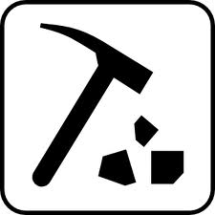
MINING ISSUES JIGSAW ACTIVITY

In this activity you will explore some issues facing the mining industry in Canada and abroad. You will be working in partners to complete your parts of the activity. You will then share your learning with your partner.

What role should First Nations people play in mining activity? Is there a resistance? | What is a treaty? How does it relate to mining activity on First Nations land? | Miner safety vs. Profit – who wins out? Give one example to support your answer.
What is the link between mining corporations and developing countries? | Diamonds = Death? What’s the connection? | What is the link between coal mining and water? Give 3 facts.
What is the impact of mining on Ontario’s economy? Give 3 facts. | What are the social and environmental impacts of mining low-grade ore? | How can Canada move towards more ethical mining practices?

