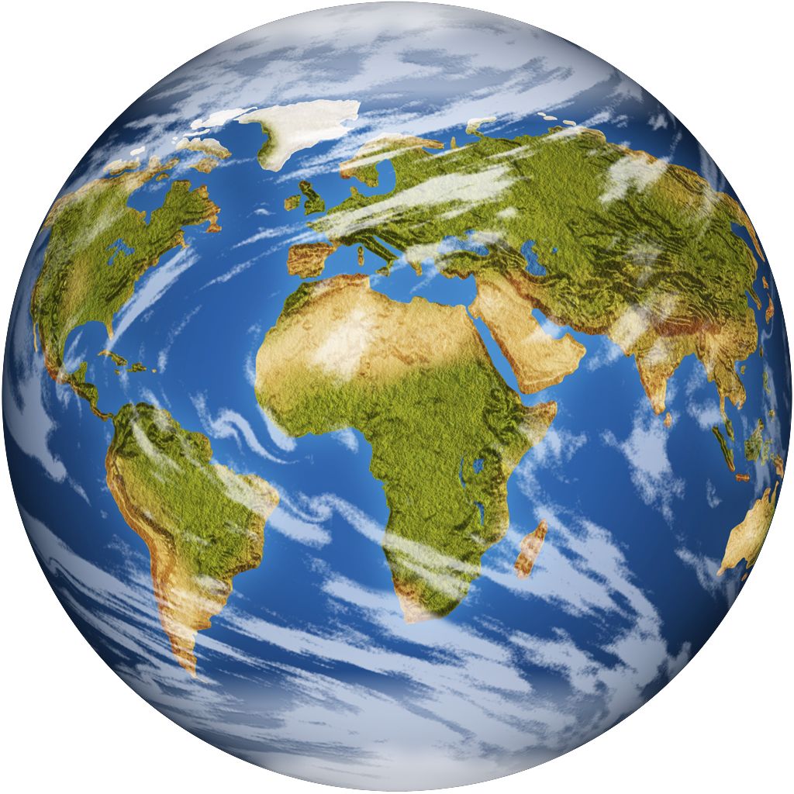
Issues in Canadian Geography - Grade 9, Academic (CGC1D)

Module 1: Environmental Justice

Conventional Energy Sources in Canada

- Electricity is _____________________________. There are various sources of electricity. All electricity starts with a power source (or fuel). Once electricity is created or ____________________, it is carried via powerlines to homes, schools, factories and offices to do work.

- List 3 ways you use electricity:

HOW DOES ELECTRICITY WORK?

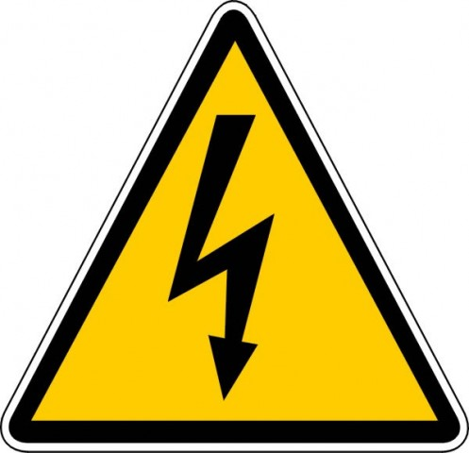
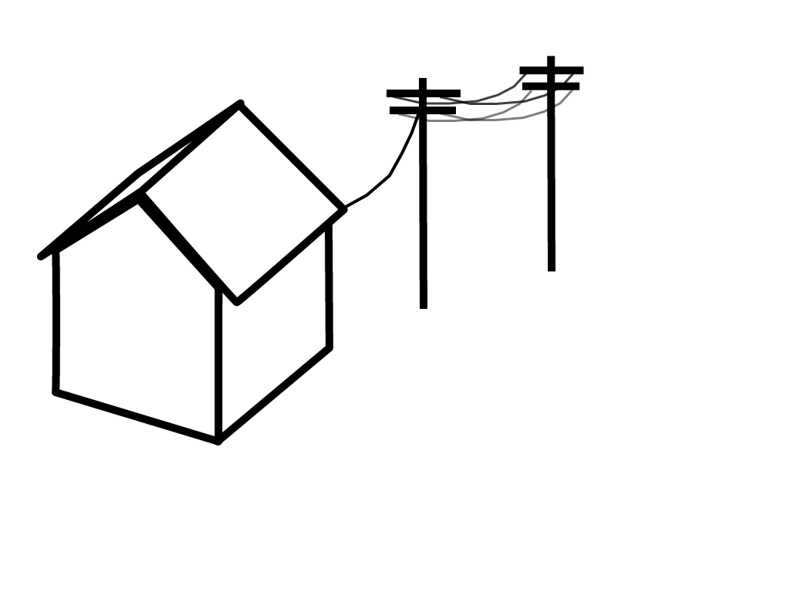





FUEL SOURCE – Hydro, Nuclear, Coal, Oil, Creation of electricity Powerlines move electricity to homes/offices Electricity powers
Natural Gas our life!

Use the page references to complete the following chart:

Energy Source |  | How is Energy Harnessed? | Advantages | Disadvantages
Hydroelectric Power

pg. 359-360
Thermoelectricity

pg. 360-361
Nuclear

pg. 361-362

